Quadrilaterals-Answers
Key Stage 3: 2003 Paper 1 Level 4-6
1.
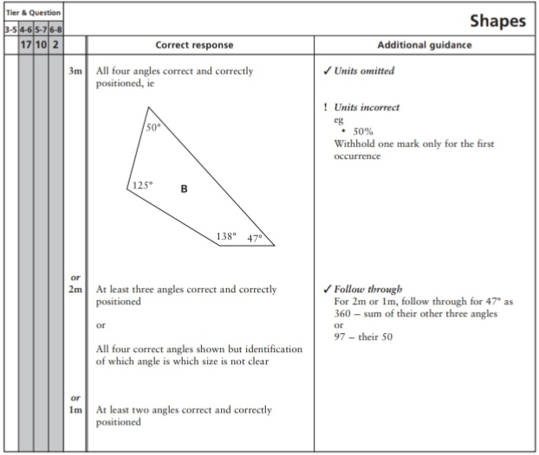
Key Stage 3: 2004 Paper 2 Level 3-5
2.
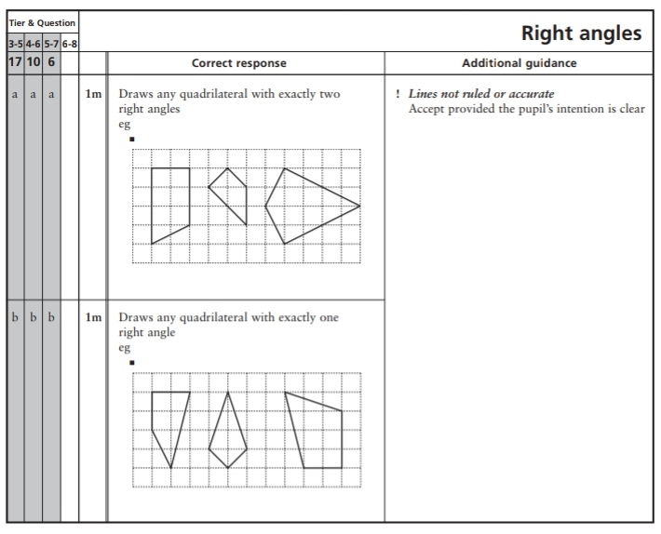
Key Stage 3: 2004 Paper 2 Level 4-6
3.
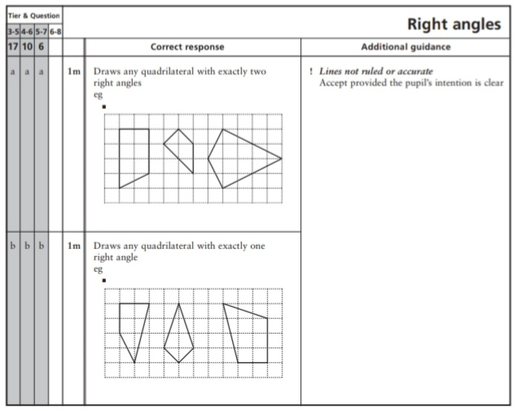
Key Stage 3: 2005 Paper 2 Level 3-5
4.
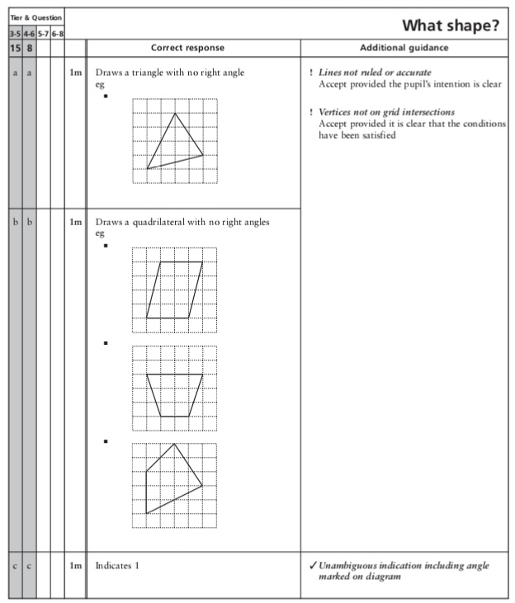
Key Stage 3: 2005 Paper 2 Level 4-6
5.
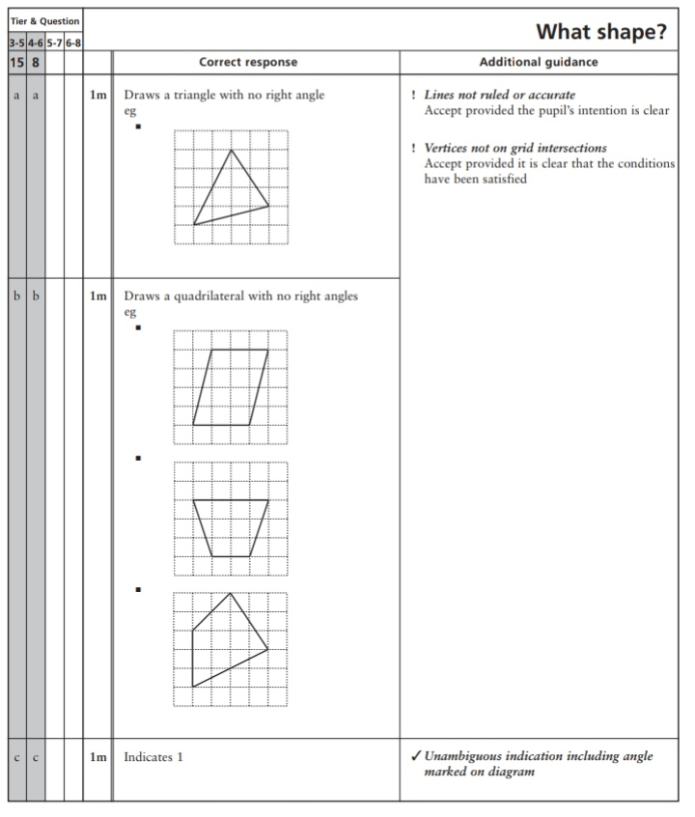
Key Stage 3: 2006 Paper 1 Level 3-5
6.
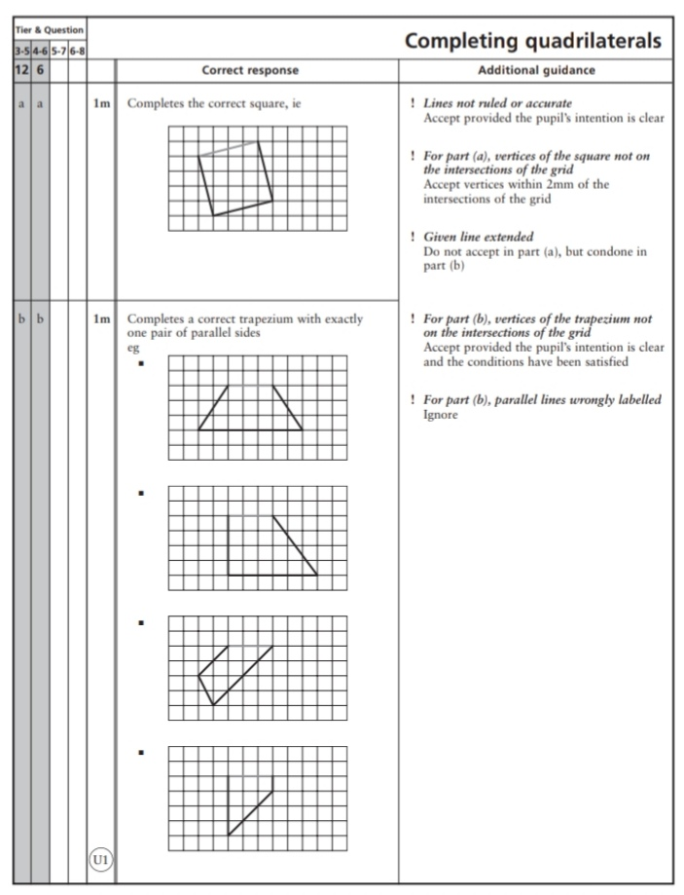
Key Stage 3: 2006 Paper 2 Level 3-5
7.
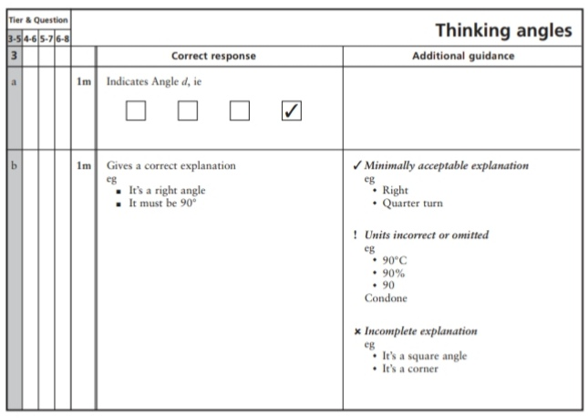
Key Stage 3: 2006 Paper 1 Level 4-6
8.
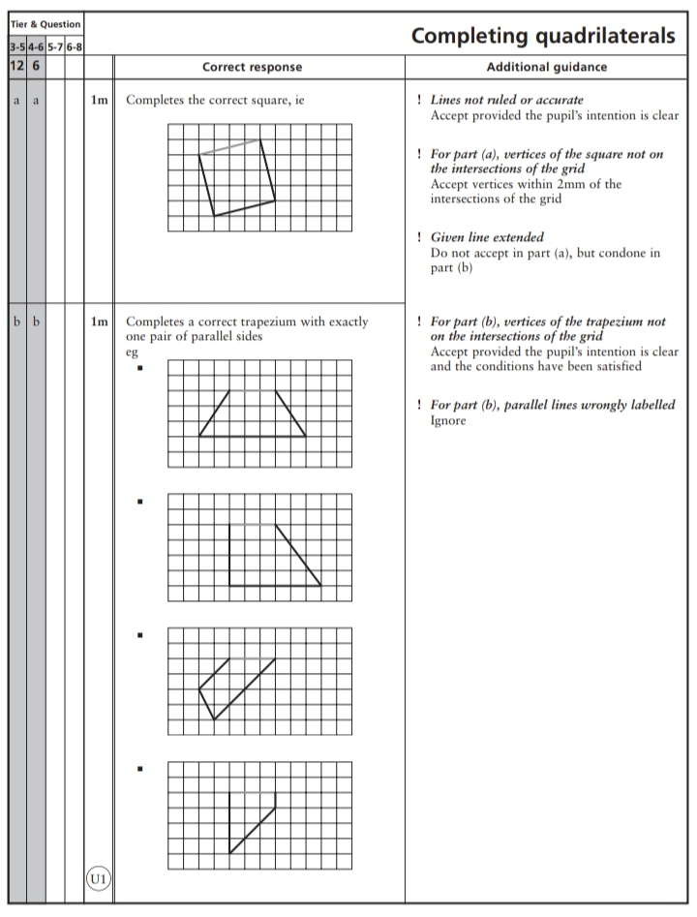
Key Stage 3: 2007 Paper 1 Level 3-5
9.
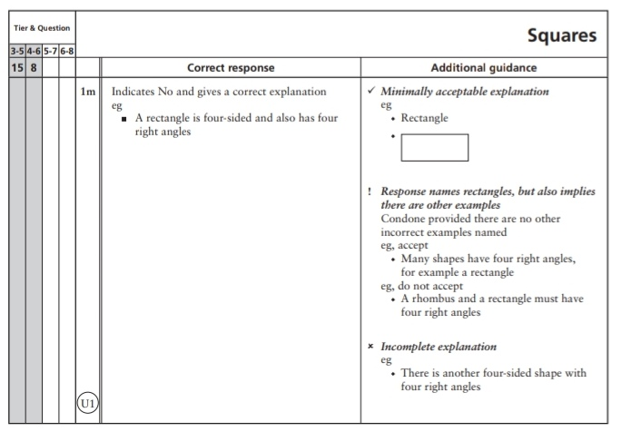
Key Stage 3: 2007 Paper 2 Level 3-5
10.
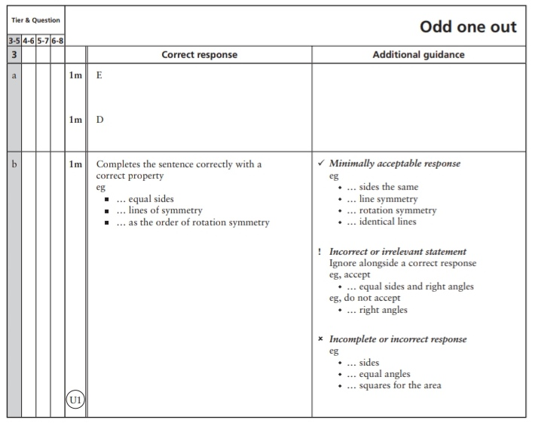
Key Stage 3: 2007 Paper 1 Level 4-6
11.
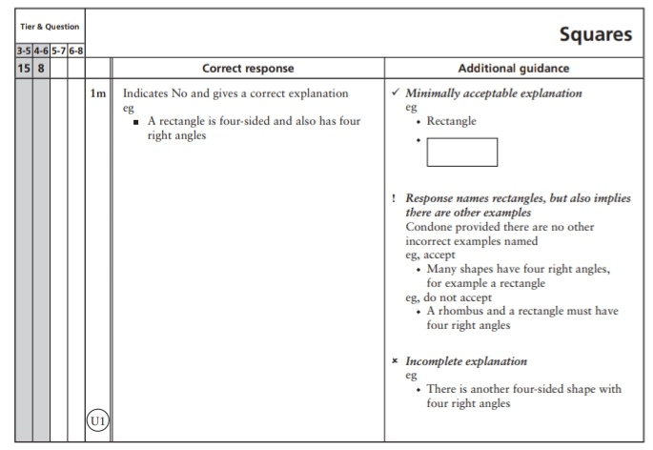
Key Stage 3: 2008 Paper 1 Level 3-5
12.
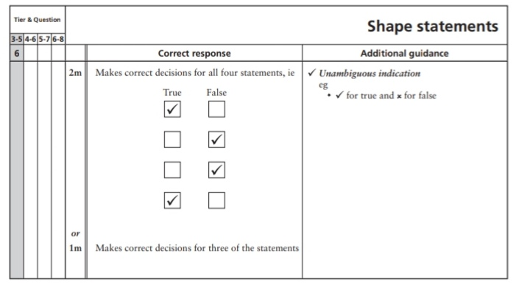
Key Stage 3: 2008 Paper 2 Level 3-5
13.
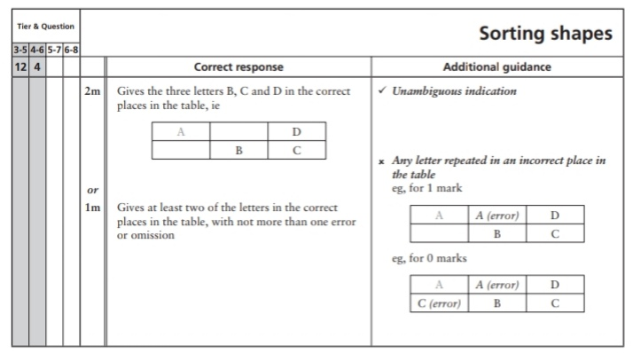
Key Stage 3: 2008 Paper 2 Level 4-6
14.
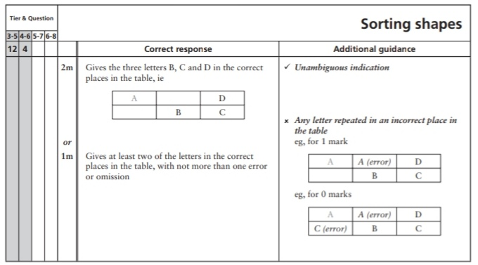
Key Stage 3: 2009 Paper 2 Level 3-5
15.
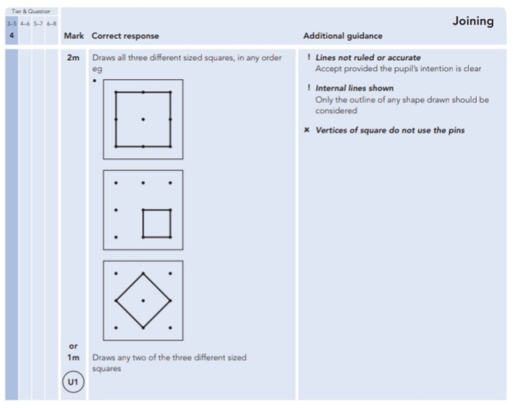
Key Stage 3: 2010 Paper 2 Level 3-5
16.
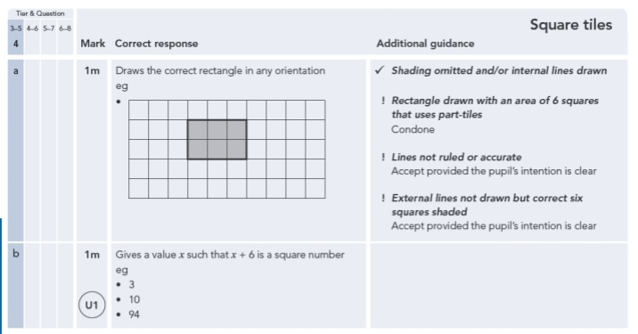
Key Stage 3: 2011 Paper 1 Level 4-6
17.
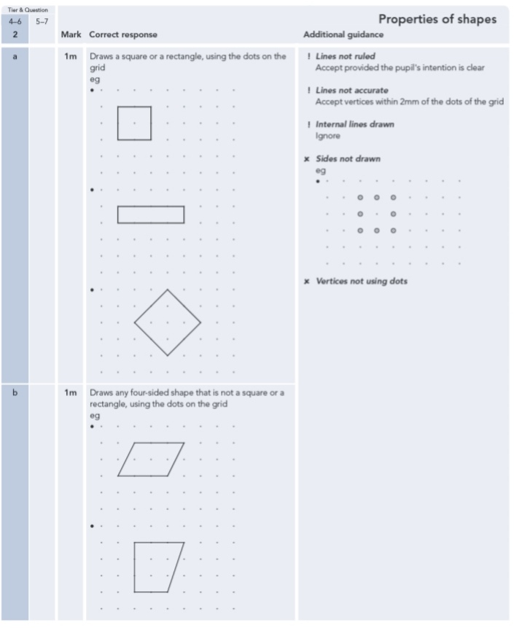
18.
